2022 LANDCARE WEEK:

Celebrating landcare diversity
MONDAY 1 – SUNDAY 7 August, 2022

About this Kit

This Communications Kit is designed to help promote 2022 Landcare Week and encourage engagement with and celebration of landcare diversity from your audience/members/stakeholders/constituents. The kit includes draft content that you can personalise:

- Social media content – to publish on your social media channels
- Newsletter articles – to include in your e-newsletters
- A letter / email – to send to your landcare stakeholders.

About 2022 Landcare Week

Landcare Week is an annual celebration of landcare during the first week of August that acknowledges the Australians who are actively restoring, enhancing and protecting the natural environment in their community.

From the coast to the country, and from urban cities to the outback, landcare’s greatest asset is its people. With over 6,000 groups and 100,000+ volunteers, the landcare movement is diverse and encompasses farmers and farming systems groups, landowners, landcare groups and networks, Traditional Owners, Bushcare and ‘Friends of’ groups, Coastcare, Dunecare and Rivercare groups, Landcare facilitators and coordinators, youth groups and other community groups involved in protecting, enhancing or restoring their local environment. The Junior Landcare program also provides a pathway for children to become lifelong landcarers starting with early learning childhood centres through to primary and secondary schools.

What makes landcare unique to any other community movement is the very large number of active groups, and the effective partnerships created between business, researchers, natural resource management agencies, government and community. These partnerships build local community ownership of issues, unlock volunteer knowledge, capability and capacity to create better outcomes for the environment and those that seek to protect and enhance it.

In the last three decades Landcare has achieved a great deal of work, yet there is much more to do. With a changing climate leading to an increase in natural disasters including drought, bushfires and floods, landcare has never been more important- united we can take action, benefitting our environment, the landscape and biodiversity, our communities and our personal wellbeing.

This Landcare Week we’ll be celebrating the diversity of landcare people and projects across Australia. We encourage you to join in on the action by sharing your landcare stories and promoting your activities with this Landcare Week Communications Kit.

SOCIAL MEDIA CONTENT

Celebrate Landcare Week: ahead of the event

Facebook / Instagram

🎉Get ready for Landcare Week, where this year we are joining @LandcareAustralia and the @NationalLandcareNetwork in celebrating the diversity of landcare people and projects across Australia!

We'll be commemorating our great landcare achievements, including how landcare brings all of us together to better our environment, the landscape and biodiversity, our communities and our own wellbeing.

Stay tuned as we share incredible landcare stories from around [insert your region here], or post yours in the comments below 👇

#landcare #landcareweek

LinkedIn

Landcare Week (Aug 1-7) is coming, and this year we will be joining @LandcareAustralia and the @NationalLandcareNetwork in celebrating the diversity of landcare people and projects across Australia!

We’ll be commemorating our great landcare achievements, including how landcare brings all of us together – landcare volunteers, landcare groups and other environmental community groups, Traditional Owners and First Nations organisations, farmers and landholders, youth groups, Landcare facilitators and coordinators, government agencies, researchers and academics.

We know that many members of our community have been struggling through drought, bushfires and floods, making landcare more important than ever. So this Landcare Week, we’ll be standing united, supporting one another and encouraging others to join our incredible movement that benefits our environment, the landscape and biodiversity, our communities and our own wellbeing.

Stay tuned as we share incredible landcare stories from around [insert your region here], and don’t forget to share yours in the comments below.

Twitter

This Landcare Week (Aug 1-7), and we are joining @LandcareAust and @NetworkLandcare to celebrate the diversity of landcare people and projects across Australia🎉
Stay tuned as we share incredible stories from around [insert your region here], or post yours below👇
#landcareweek

Celebrate Landcare Week: how to share your stories

This year’s Landcare Week theme is Celebrating Landcare Diversity, so we would recommend sharing a number of social media posts about a diverse range of landcare projects you are involved in, individual landcarers in your group, or events you would like people to attend.

Themes for your posts could include:
- Landcare volunteer profile
- Bushcare project profile
- Coastcare project profile
- Agricultural project profile
- A project you worked on in partnership with others
- A Junior Landcare or youth focussed project
- A community workshop or open day you are holding for Landcare Week

Make sure to include at least one image of the project/landcarer in your post, tag us at @LandcareAustralia and @NationalLandcareNetwork (Facebook/Instagram) or @LandcareAust and @Network Landcare (Twitter), and use #landcareweek.

Example post [do not post to your own page]:

This Landcare Week, we want you to meet local landcare champion Margaret Moir: a conservation trailblazer who has been taking action in our region for over 30 years!

From her prolific work in river restoration and regeneration, to her fantastic guide on woody weeds of the Cape Naturaliste to Cape Leeuwin region, Margaret has been a fantastic leader of the landcare community here in Margaret River (she even helped establish Nature Conservation Margaret River Region) 🌱

A big thank-you to Margaret for all her incredible work which has seen her nominated for the 2022 Australian Government Individual Landcarer Award, and stay tuned for her second glovebox guide to non-woody weeds in our region that’s currently underway!

#landcareweek @LandcareAustralia

MARKETING ASSETS

Social Media

Facebook / LinkedIn
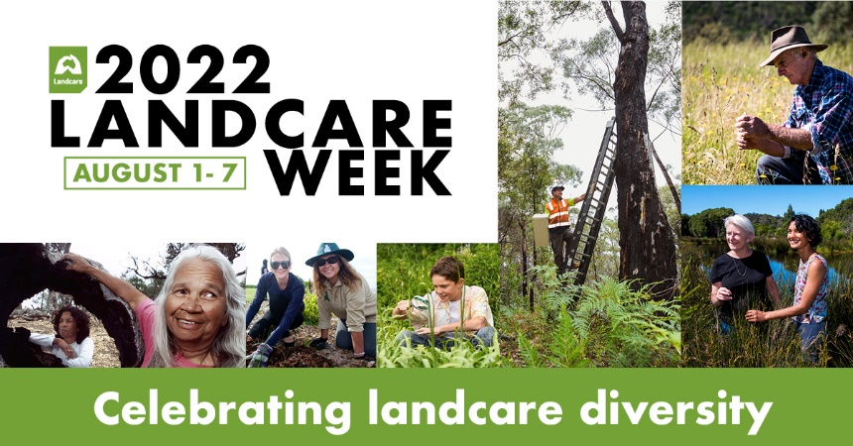

Twitter
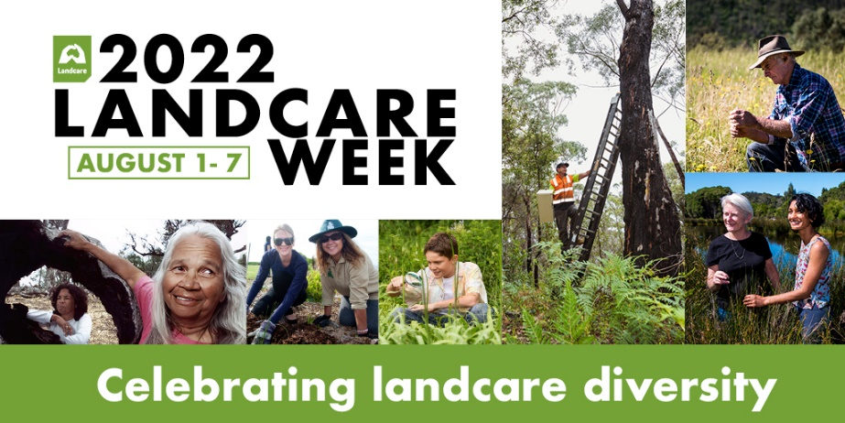

Instagram
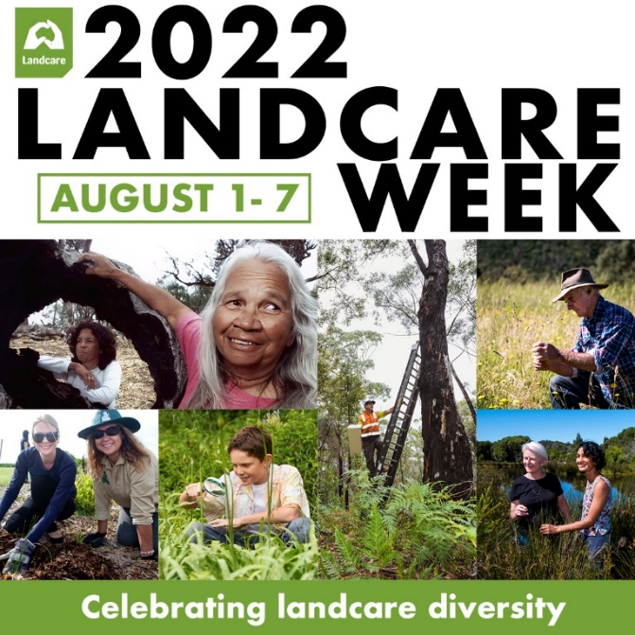

NEWSLETTER ARTICLES
Celebrate Landcare Week

Celebrate Landcare Week with us!

Get ready for Landcare Week (August 1- 7), where this year we are celebrating the diversity of landcare people and projects across Australia!

Together, we'll be commemorating our great landcare achievements, including how landcare brings all of us together – landcare volunteers, landcare groups and other environmental community groups, Traditional Owners and First Nations organisations, farmers and landholders, youth groups, Landcare facilitators and coordinators, government agencies, researchers and academics.

We know that many of us have been struggling through drought, bushfires and floods, making landcare more important than ever. So this Landcare Week, let's stand united, support one another and encourage others to join our incredible movement that benefits our environment, the landscape and biodiversity, our communities and our own wellbeing.

For more information on our Landcare Week activities and to read about some incredible landcare stories, stay tuned to our Facebook page here: [insert link to your Facebook page]

MARKETING ASSETS

Newsletters

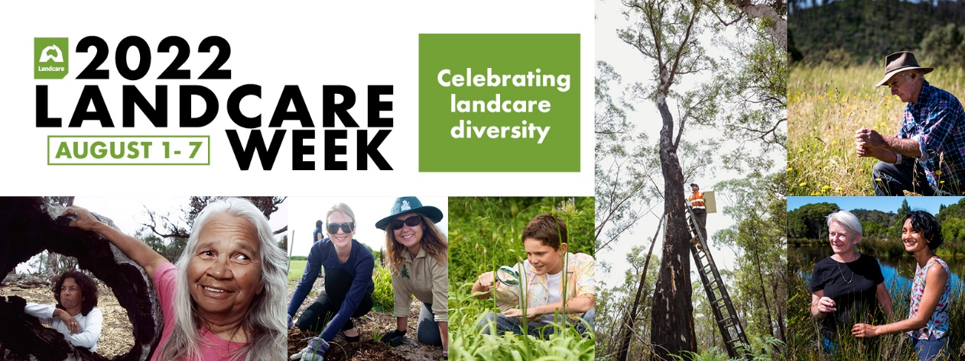

email / letter template

Email or Letter to an Individual or Group

Dear [Name],

Join [insert organisation name] in celebrating Landcare Week from August 1-7 – this year’s theme is Celebrating Landcare Diversity.

For over 30 years, landcare has been bringing everyone together: landcare volunteers, landcare groups and other environmental community groups, Traditional Owners and First Nations organisations, farmers and landholders, youth groups, Landcare facilitators and coordinators, government agencies, researchers and academics.

We know that many of us have been struggling through drought, bushfires and floods, making landcare more important than ever. So this Landcare Week, let's stand united, support one another and encourage others to join our incredible movement that benefits our environment, the landscape and biodiversity, our communities and our own wellbeing.

We’d love for you to get involved in Landcare Week. For more information on our activities, and to read some incredible landcare stories or even share your own, please visit our Facebook page here: [insert link to your Facebook page]

Yours sincerely,

[Name of sender]

MARKETING ASSETS

Email Signature

